Power Economics and Emissions Student Notebook

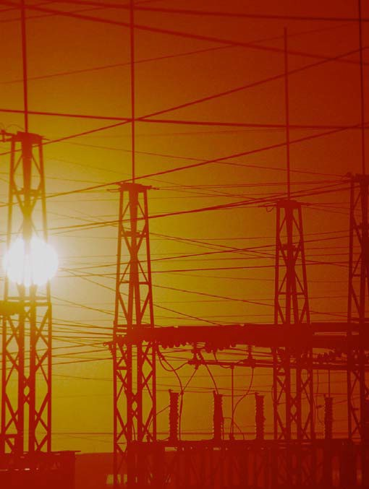

TCIP Educational Development
TCIPG: Trustworthy Cyber Infrastructure for the Power Grid

Lesson 1 Power Economics and Emissions

Communities and Payments

Use the applet at http://tcipg.mste.illinois.edu/applet/eco to explore some of the economics of generating and using electricity. In the applet there are five different types of generators delivering electricity to three communities. You can see the total payments per hour for each of the communities and the costs and emissions per hour for each of the generators.
- Change the amount of electricity each of the communities is demanding. What else can you change?

When the applet opens or you press the Reset System button, the communities are paying $90 per megawatt per hour (MWh) for the electricity they are using. The amount a customer pays depends on the rate charged, the amount of power used, and the number of hours it is used.
Notice the power demand from the three communities. Residenceburg is demanding 1,700 MW; Commerceton, 850 MW; and Industryville, 850 MW. These three locations are the consumers of the electricity. That is, they are the customers that purchase power from the system.
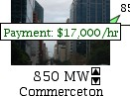
- How much are the total payments to the power producers from Industryville, Commerceton, and Residenceburg each hour?
- Click on the up or down arrow under the Commerceton image to change the demand for electricity from this community. What happens when you click the up arrow? What happens when you click the down arrow?

- How much is Commerceton’s payment per hour when the MW demand is 500 MW?

- What happens when you increase the demand from Residenceburg to 2000 MW? What about 2050 MW?

Lesson 2a Power Economics and Emissions

Generation Costs and Emissions

Use the applet at http://tcipg.mste.illinois.edu/applet/eco to explore some of the economics of generating and using electricity.
- Press the Reset System button and then complete this chart.
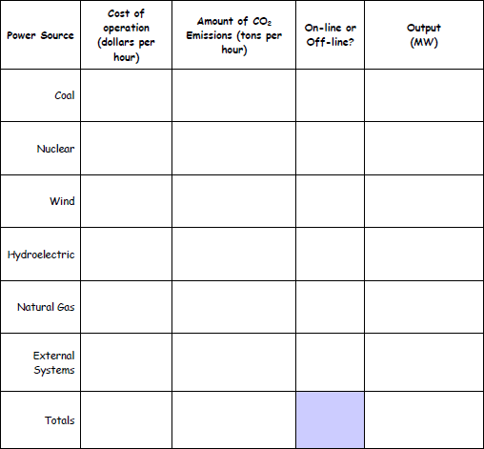

- All of the generators have operation costs whether they are on-line or off-line. Why might that be? Which generators have the largest off-line costs? Is this related to the maximum capacity of the gener- ator?

Lesson 2b Power Economics and Emissions

Generation Costs and Emissions

When the applet at http://tcipg.mste.illinois.edu/applet/eco opens or the Reset System button is clicked, two generators are producing electricity and the coal generator is producing carbon dioxide emissions. There are costs and emissions associated with the power from the external system. We do not always know the source of this power so the applet uses an average based on representative generation types for the U. S.
- The applet shows costs and emissions information for each generator. Click the up and down arrows under the generators to change the production. What else changes.?

- Complete the chart below using information from the coal generator. How do the costs and emissions increase with the increase in power production?
Coal Generator Costs and Emissions
Power produced (MW) | Costs  ($ per hour) | CO₂ emissions (tons per hour)
0
300
400
500
600
700

- Switch the coal generator offline. What are the costs and emissions now?

- When a generator is offline, there are no emissions or fuel costs, but there are still fixed costs asso- ciated with operating and maintaining the generator.
How much are fixed costs for each generator? Coal Natural gas

Wind
Hydropower
Nuclear

Lesson 2c Power Economics and Emissions Generation Costs and Emissions
Press the Reset button.
Look at the coal generator. Notice that it is producing 600 MW at a cost of $14,000 per hour. Change the amount of power the generator is producing and notice what happens to the cost per hour.
- Complete this table that compares the power produced to the cost per hour for the coal generator.
Coal Generator Costs
Power produced (MW) | Cost per hour ($ per hour)
0
300
400
500
600 | $14,000
700

- Write a sentence to describe the relationship between the power produced and the cost per hour.

- Write an algebraic equation to describe the relationship be- tween the power produced and the cost per hour.

Graph this function.

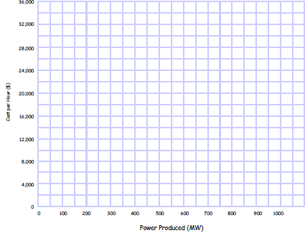

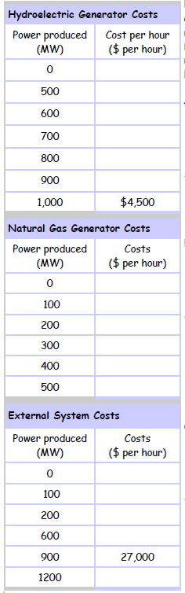
Complete these tables that compare the power produced to the cost per hour for the hydroelectric
generator, the natural gas generator, and the external sys-
- tem. For each, write a sentene to describe the relationship between the power produced and the cost per hour. Write algebraic equations for each to describe the relationship between the power produced and the cost per hour. Graph each on the same grid as the graph for the coal generator on the previous page.
  - Sentence describing relationship:

Algebraic equation:

5.

  - Sentence describing relationship:

Algebraic equation:

6.

  - Sentence describing relationship:

Algebraic equation:

Use the graphs you made to answer these questions.
  - How do these graphs help explain the cost of running the different types of generators? What can be learned by studying these graphs?

  - How does the cost of power from the external system compare to the costs associated with the generators in this system?

  - If 500 MW of power is needed, what is the cost of running each of these generators or of getting the power from the external system?

  - Compare the natural gas generator to the other generators. When might you use the natural gas generator? Why does the cost of using the natural gas generator increase so quickly? What could be some reasons for using natural gas instead of coal or hydroelectric generators?

  - What characteristics of the wind generators and the nuclear generator prevent them from being graphed on the graph you created?

DOE/EIA
Date of Data: 2009
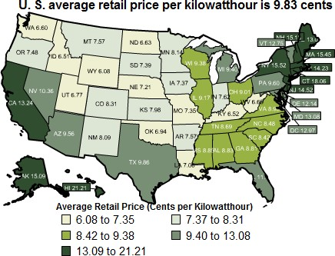
Data Release Date: April 2011 DOE/EIA-

Data is displayed as 5 groups of 10 states and the District of Columbia. Source U.S. Energy Information Administration. Find more information and an interactive map at www.eia.gov/ectricity/sales_revenue_price/index.cfm
8

Total kWh
08/13/2008
2989.0000
Summer kWh 08/13/2008
2989.0000
ELECTRIC SERVICE BILLING DETAIL
DS - Residential (DS-1)
Service From 07/17/2008 to 08/13/2008
Former Space Ht Acct 15k And Over
Total kWh
02/14/2008
6153.0000
Non-Summer kWh
02/14/2008
6153.0000
ELECTRIC SERVICE BILLING DETAIL

Customer Charge |  | $6.29
Meter Charge |  | $3.62
Distribution Deliv Chg Summer | 2,989.00 kWh @ $.03203000 | $95.74
Electric Environmental Adj | 2,989.00 kWh @ $.00081680 | $2.44
Instrument Funding Charge | 2,989.00 kWh @ $.00690000 | $20.62
Instrument Funding Credit |  | -$20.62
Rider EDR Charge | 2,989.00 kWh @ $.00037859 | $1.13
Total Delivery Service Amount |  |  | $109.22
Electric Supply (BGS-1) Service From 07/17/2008 to 08/13/2008
Purch Elec Summer 2,989.00 kWh @ $.06385000 |  | $190.85
Market Value Adj 2,989.00 kWh @ $.00150110 |  | $4.49
Rider PER Supply Cost Adj 2,989.00 kWh @ $.00070000 |  | $2.09
Transmission Service Charge 2,989.00 kWh @ $.00318000 |  | $9.51
Total Supply Amount |  |  | $206.94
Taxes Service From 07/17/2008 to 08/13/2008
Illinois State Electricity Excise Tax $9.75
Total Tax Related Charges $9.75

Total Electric Charges $325.91

DS - Residential (DS-1) Service From 01/15/2008 to 02/14/2008 Former Space Ht Acct 15k And Over  Customer Charge | $6.30
Meter Charge | $3.62
Distribution Deliv Chg Non-Summer 6,153.00 kWh @ $.01998000 | $122.94
Electric Environmental Adj 6,153.00 kWh @ $.00096420 | $5.93
Instrument Funding Charge 6,153.00 kWh @ $.00670000 | $41.23
Instrument Funding Credit Total Delivery Service Amount | -$41.23 | $138.79
Electric Supply (BGS-1) Service From 01/15/2008 to 02/14/2008 Non-Summer (0-800 kWh) 800.00 kWh @ $.07957000 | $63.66
Non-Summer (Over 800 kWh) 5,353.00 kWh @ $.01024000 | $54.81
Market Value Adj 6,153.00 kWh @ $.00004400 | $0.27
Supply Cost Adj 6,153.00 kWh @ $.00074000 | $4.55
Transmission Service Charge 6,153.00 kWh @ $.00247000 Total Supply Amount | $15.20 | $138.49
Taxes Service From 01/15/2008 to 02/14/2008 Illinois State Electricity Excise Tax | $19.85
Total Tax Related Charges |  | $19.85
Total Electric Charges |  | $297.13

Lesson 3a Power Economics and Emissions

Payments

Use the applet at http://tcipg.mste.illinois.edu/applet/eco to explore some of the factors associated with the price of electricity. When the applet opens or you press the Reset System button the Load Payment slider is set at $90/MWh.
- What changes when you move slider?

The Load Payment slider on the applet shows the payment per MWh. To change $0.0983 per kWh to dollars per MWh multiply by 1000. (1000 kWh = 1 MWh
The map of the United States on page 8, shows average residential retail prices in 2009 in cents per kWh of electricity for the entire U.S. and for individual states. Move the Load Payment slider to represent the U.S. average. Round to the nearest whole dollar per MWh.

- If one million people in Residenceburg each use an amount of electricity equal to two 100 watt light bulbs, the demand from the community is 200 MW. What is the per hour payment from Residenceburg for this electricity?
- If Residenceburg is in MN, then what is the payment from

Residenceburg if the demand is 1000 MW?
- Move the Load Payment slider to represent the retail price of electricity in your state. What is the payment for Residenceburg if the demand is 1800 MW?
- Which state has the highest price for electricity? Which has the lowest? Why do you think the states’ rates vary so much?
1,000,000 people demanding 200 watts makes the demand 200,000,000 watts. 200,000,000 w = 200,000 kw = 200 MW
With the Load Payment slider se at
$98, adjust the demand from Residenceburg to 200 MW to see the per hour payment.

Utilities may have different rates for their business and industrial customers and may also vary their rates with the season. Look at some sample utility bills. You may be able to get sample bills and guidelines about how to read them from your local electric utility.

Lesson 3b Power Economics and Emissions

Payments

Use the sample bills on page 9 to answer these questions.
- How many kWh of electricity did this family use during the time period, 07/17/2008 to 08/13/2008?

- What is the distribution delivery charge rate for summer?

- What is the distribution delivery charge for summer?

- How much does the family pay for the meter?

- What is the total delivery service charge for the time period, 07/17/2008 to 08/13/2008?

- What is the total supply charge for the time period, 07/17/2008 to 08/13/2008?

- How much are taxes for the time period, 07/17/2008 to 08/13/2008?

- How many kWh of electricity did this family use during the time period, 01/15/2008 to 02/14/2008?

- What is the distribution delivery charge rate for non-summer?

- What is the distribution delivery charge for non-summer?

- How much does the family pay for the meter?

- What is the total delivery service charge for the time period, 01/15/2008 to 02/14/2008?

- What is the total supply charge for the time period, 01/15/2008 to 02/14/2008?

- How much are taxes for the time period, 01/15/2008 to 02/14/2008?

- Why do you think the electric supply cost is higher in summer even though the family uses more kwh of electricity in the winter?

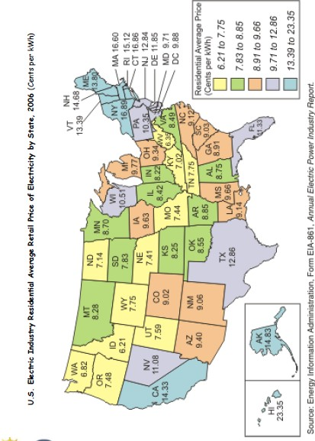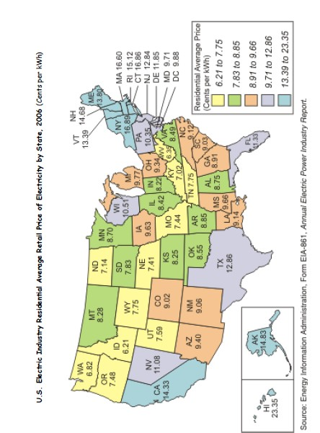

Lesson 3c Power Economics and Emissions

Payments

The map on page 12 shows the average cost of electricity for residential customers across the United States in 2006.
  - How does it compare with the map on page 8 that shows similar information for 2009?

  - Name five states that had a decrease in price.

  - Name five states that had a increase in price.

  - Did the average retail price for Texas increase or decrease? Why might that have happened?

Use the information from the 2006 and 2009 maps on pages 8 and 11 to answer the following questions.

  - Use the average cost per kWh for each state to create box and whisker plots for both years

  - Find the mean, median, mode, and range for both years

  - Which states costs are shown as outliers? Can you explain why?

Lesson 4a Power Economics and Emissions

Generation and Delivery

When the applet at http://tcipg.mste.illinois.edu/applet/eco opens or the Reset System button is pressed, two generators are producing electricity and three are not.
- How much power is each generator producing? Coal Natural gas

Hydropower
Wind
Nuclear

- How much is the total power production?
- How much total power are the three communities demanding?
- Since these generators are not producing as much power as the communities are demanding, the sys- tem needs to import power from the external system. How much power is the external system providing?
- How much are the supply costs per hour (generators and external system)?

Coal
Natural gas
Hydropower

Wind Nuclear External system total
- What is the cost for Transmission and Distribution?
- What are the producer’s total costs? That is, how much per hour is the producer spending altogeth- er (including the external system costs) to provide power to these three locations?

- Are the power provider’s costs more or less than the payments from the communities? How much is the provider’s profit or loss?
- What happens when you switch on the nuclear power plant?

Now how much is the provider’s profit or loss?
- What happens when you switch on the wind farm?

How much is the provider’s profit or loss now?
- Without changing the demand from the communities, maximize the provider’s profits. How much is the provider’s profit?
- What did you do to maximize the profits?

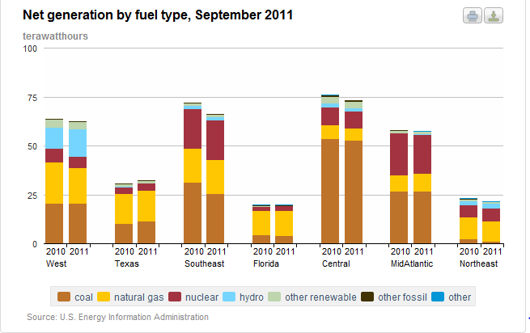
These resources are used to produce electricity. Electricity supplied from the grid is consumed the moment it is produced. The electricity market chooses generation units so that the least expensive generators supply electricity first. The graph and chart show generation output by fuel type (which primarily determines generation expense) for seven regions of the U.S.
Find more information and an interactive graph at http://www.eia.gov/electricity/monthly/update/resource_use.cfm

Generation measured in million gigawatthours | WE ST |  | TEX AS |  | SOUT HEAST |  | FLOR IDA |  | CEN TRAL |  | MidATL ANTIC |  | NORTH EAST
 | 2010 | 2011 | 2010 | 2011 | 2010 | 2011 | 2010 | 2011 | 2010 | 2011 | 2010 | 2011 | 2010 | 2011
Coal | 20.51 | 20.25 | 10.23 | 11.34 | 31.12 | 25.58 | 4.48 | 3.99 | 53.39 | 52.83 | 26.66 | 26.5 | 2.18 | 0.93
Natural Gas | 21.11 | 18.51 | 15.03 | 15.61 | 17.44 | 17.38 | 12.44 | 12.83 | 7.22 | 6.21 | 8.29 | 9.08 | 11.12 | 10.24
Nuclear | 6.88 | 13.75 | 3.64 | 3.66 | 20.24 | 19.97 | 1.96 | 2.25 | 9.02 | 8.56 | 21.4 | 19.92 | 6.22 | 6.69
Hydro | 10.9 | 13.75 | 0.06 |  | 1.76 | 1.82 |  |  | 1.89 | 1.8 |  | 0.66 | 2.29 | 2.74
Other renewables | 3.99 | 4.04 | 1.45 | 1.54 | 1.32 | 1.32 |  |  | 3.53 | 3.06 | 1.18 | 1.05 | 0.8 | 0.7
Other fossil | 0.29 | 0.28 | 0.23 | 0.21 | 0.41 | 0.37 | 0.65 | 0.32 | 0.88 | 0.86 | 0.29 |  | 0.23
Other |  |  |  |  |  |  | 0.36 | 0.34 | 0.24 |  |  | 0.19 | 0.43 | 0.46
Total | 63.68 | 70.58 | 30.64 | 32.36 | 72.29 | 66.44 | 19.89 | 19.73 | 76.17 | 73.32 | 57.82 | 57.4 | 23.27 | 21.76
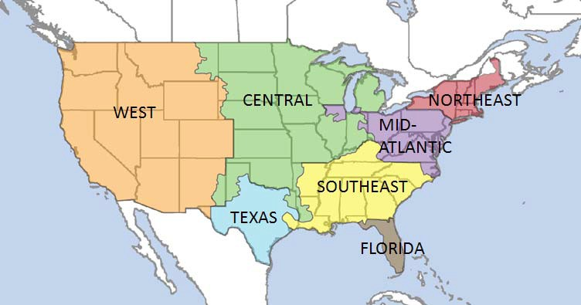

Name

Lesson 4b Power Economics and Emissions

Generation and Delivery

The chart and table on the previous page show energy sources used for production of electricity for various regions of the United States.
- Which region uses coal for more than 50% of their electricity production?
- Which region has the highest percentage of nuclear generation?
- Which region has the highest percentage of hydroelectric generation? Why might this be?

- Find out more about renewable energy at http://www.nrel.gov/rredc/. What energy sources are in- cluded in “other renewables”?

- Which regions have higher amounts of generation from these renewable energy source?

- Compare this map with the map on page 8. What do you notice? Explain the relationships between the energy sources and the price of electricity?

- How do available resources and public policies influence energy sources used for generation of elec- tricity?

- The U.S. Energy Information Administration publishes state energy profiles on their website at http://www.eia.gov/state/index.cfm . How and why do states’ energy sources differ? Give some exam- ples.

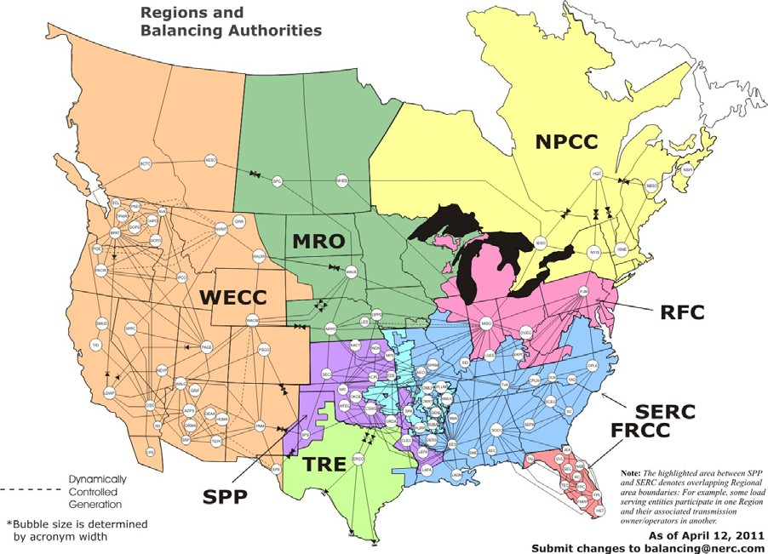North American Electric Reliability Corporation (NERC) works with eight regions to improve reliability of the power sys- tem. Its members represent all parts of the electric industry. www.nerc.com

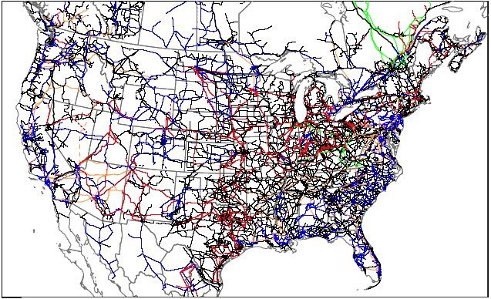
Transmission in the Contiguous United States

Lesson 4c Power Economics and Emissions

Generation and Delivery

Compare the maps of the United States on pages 15 and 17.
- How is the map at the bottom of page 15 different from the NERC Regions map on page 17?

- Why do you think Texas and Florida have their own regions? What do you notice about the infor- mation on page 8 for these two states?

- Which states have more transmission lines? Why do you think this is?

Lesson 4d Power Economics and Emissions

Generation and Delivery

Use the applet at http://tcipg.mste.illinois.edu/applet/eco to explore how systems of electricity are interconnected. When the applet opens or you press the Reset System button, Residenceburg is using 1,700 MW per hour, Commerceton is using 850 MW per hour, and Industryville is using 850 MW per hour.
  - What happens to the External System cost when each of these three locations increases the amount of power they need?

  - What could cause each of these locations to have to increase the amount of energy they need?

  - What could cause each of these locations to have a decrease in the amount of energy they need?

  - Press the Reset System button. Currently, the system is spending $54,000 to purchase energy from external systems. Can you find a way to set the system so that this system does not have to rely on external systems to meet the needs of its customers?

  - Complete these charts to show what changes you make to the system so that no power is going to or from the External System. How much of a profit or loss does your system have? What are the emissions?

Power Source | Cost of operation  (dollars per hour) |  | Amount of CO₂ Emissions  (tons per hour) |  | On-line or  Off-line? | Output  (MW)
Coal
Nuclear
Wind
Hydroelectric
Natural Gas
External Systems
Customers |  | Energy Demand (MW)
Residenceburg
Commerceton
Industryville
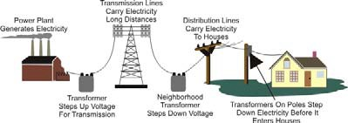
Source: Energy Information Administration
Dollars received from customers
Expense to provide power to customers (Be sure to include
the transmission and distribution costs!)
Total Emissions/hour

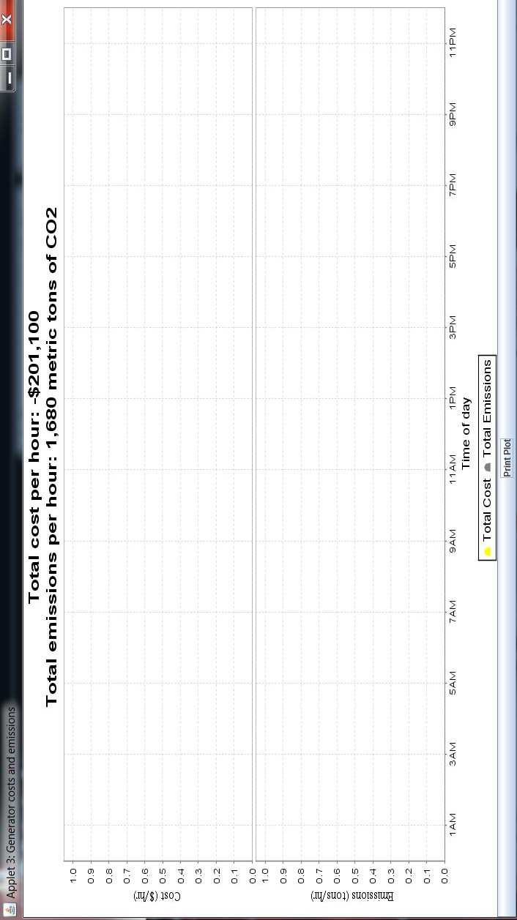

Utility Profits and Emissions
    - Use the applet at http://tcipg.mste.illinois.edu/applet/eco to explore some of the economics of generating and using electricity. Press the Reset System button, then press the Reset Time but- ton and the Show Plot button. Let the system run until the graph shows several hours. Press Pause Time. You should see a plot that looks like the one below. What does it show?

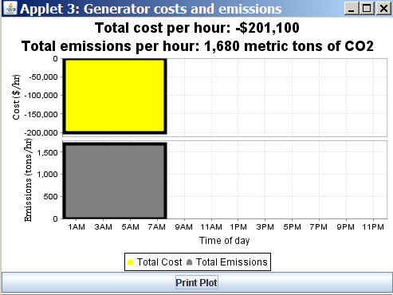
The yellow part of the graph shows the cost per hour to the utility. When the cost is negative, the utility’s costs are less than the payments from the communities and it is making a profit.
    - How much profit per hour does the graph
show for the utility? Is this
the same as you calculated in the previous les- son?

    - The grey part of the graph shows the carbon dioxide (CO₂) emissions produced per hour. How much CO₂ is the system producing?
    - These plots show costs and emissions for about eight hours. During that time period how much profit did the utility make? and how many metric tons of CO₂ were released
into the atmosphere? Why are we concerned about both costs and emissions?

    - Press the Reset Time button. Keep the power demand from Residenceburg at 1700 MW and from Commerceton and Industryville at 850 MW each. Adjust the system so that the utility is making a profit and the CO₂ emissions are lower than 1000 metric tons per hour, then click the Show Plot button, and let the system run until the graph shows several hours. Then press Pause Time. Shade this plot to look like what you see. Complete this chart for the system.

Generator | Power Production | CO_{a} Emissions
Coal
Wind
Natural gas
Hydropower
Nuclear
External system sources

Lesson 6 Power Economics and Emissions

Emissions and Climate Change

Use the applet at http://tcipg.mste.illinois.edu/applet/eco to explore carbon dioxide emissions produced when generating electricity. Press the Reset System button. Then turn on the Natural Gas, Nuclear and Wind Generators so all of the generators are producing.
- Look at the Coal Generator. Notice the Coal Generator power output is 600MW and it has carbon dioxide emissions of 600 tons per hour. Change the amount of power produced. How do the emissions change?

- The emissions shown in this applet are carbon dioxide (CO₂) emissions. Carbon dioxide is a greenhouse gas. Which generators produce CO₂ emissions?

- How do the emissions for the Coal Generator compare to the emissions for the each of the other generators?

- How do the emissions change as the power production changes?

- This graph shows sources of CO₂ emissions for the United States in 2009. What information does the graph give you?

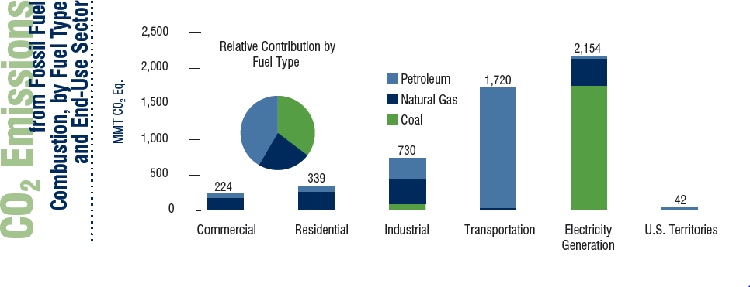

Source: U.S. Greenhouse Gas Emissions Inventory (y-axis units are metric tons of CO2 equivalent).

Lesson 7 a Power Economics and Emissions

Off the Grid

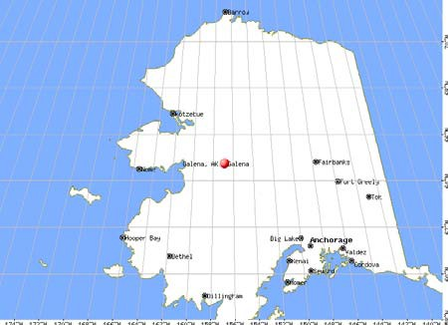
Some remote parts of the United States are a long way from the interconnected power grid in the 48 contiguous states and Canada. Most con- sumers of electricity in Alaska are not linked to any large grid. Areas near Fairbanks and An- chorage have their own isolated grid, but remote or rural locations such as Galena, Alaska rely on their own generators. The city of Galena has six diesel powered generators with 4300 kw capaci- ty. The town is located on the Yukon River about 270 miles west of Fairbanks and 550 miles north of Anchorage. Its population is about 700 people.
During the winter large volumes of fuel cannot be shipped to Galena because of its remote location. That means that any fuel the town may need must be shipped and stored during the summer months.
Shipping and storing the 3 million gallons of fuel the town needs over the winter greatly increases the cost of electricity. Residents pay over $.30 per kWh.
- How does this cost compare to the average for the United States?
Town leaders in Galena, AK conducted a study to determine what could be done to reduce the cost of elec- tricity. Their study included the advantages and disadvantages of hydroelectric, coal, wind, solar,and nu- clear generators.
- Can you think of the problems each of these types would have that would eliminate it as a solution for their high costs of electric?

Type of Generator | Problem
Hydroelectric
Coal
Wind
Solar
Nuclear
You can find the Galena report prepared for the U.S. Department of Energy at www.iser.uaa.alaska.edu/Publications/Galena_power_draftfinal_15Dec2004.pdf

Lesson 7 b Power Economics and Emissions

Off the Grid

In 2004, the people of Galena entered an agreement with Toshiba and the Central Research Institute of Electric Power Industry (CRIEPI) of Japan that would bring a small nuclear
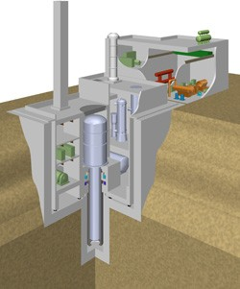power generator to Galena. The system they hope to build is a new technol- ogy called Toshiba 4S. The Toshiba 4S stands for Super, Safe, Small and Simple. Under this agreement the company will construct the 10 MW plant free of charge, but the town must assume operation costs. It is estimated that the cost of electricity for Galena residences might decrease to $.10 kWh when this plant is on-line. This plant is still in the planning stages and has not been approved by the Nuclear Regulatory Commission yet. If the Nuclear Regulatory Commission approves this project it will be the first approval in more than twenty years. Galena is hoping that the nuclear gen- erator could be operating by 2012 or 2013.

Toshiba 4S small, sodium cooled, underground reactor
- Why do you think this process takes so long?

- How would this new price per kwh of electricity compare to the U.S. average?

- How does the power capacity of this small nuclear generator compare with other generators that we have been looking at? How does it compare with a single wind turbine?

- Consider the population size of Galena. Will this small nuclear generator supply enough power for the town?

- Why do you think the Japanese company would be willing to pay for the cost of constructing the Toshi- ba 4S?

Read more about this project at: http://www.roe.com/about_techgalena.htm
http://atomicinsights.com/2005/03/nuclear-power-for-galena-alaska.html http://green.blogs.nytimes.com/2009/06/30/big-alaska-looks-to-small-nuclear/

Another remote location in Alaska is the state’s capitol, Juneau. Juneau is inaccessible except by air or water. The Mendenhall Glacier cuts off all land routes to Juneau. Juneau’s Alaska Electric Light & Power Co. provides electricity to Juneau using primarily hydroelectric generation.
In April, 2008, an avalanche cut transmission lines between the main plant and the city. While repairs were being made, Juneau was getting its electricity from a diesel fueled generator. The price of electric- ity increased from $.11 kWh to $.53 kWh. The people in the city of Juneau reacted by decreasing elec- tricity use by 30% in just a few weeks. These are a few of the things people did to reduce their use of

electricity:
- 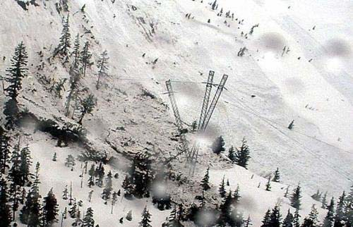Unscrewing or replacing light bulbs with fluores- cent bulbs
Courtesy Of Mike Laudert / Alaska Electric Light & Power Co.
April 16, 2008 - Power disaster: Above, an electric transmission tower that was caught in the avalanche is shown Wednesday about three miles from the Snettisham Power House, about 40 miles south of Juneau. Electric rates in Juneau are expected to rise sharply as Alaska Electric Light & Power Co. switches to diesel power while the structures are repaired.
- Turning the heat down to 60 degrees F
- Drying clothes on clothes lines instead of using a dryer (This is dif- ficult because Juneau is in the middle of a rain forest and it rains 220 days a year.)
- Turning off runway lights at the airport when no planes are landing
- Turning off televisions and computer games
Avalanche Knocks Out Hydropower

For more information about Juneau’s power outage go to: http://www.nytimes.com/2008/05/14/us/14juneau.html http://juneauempire.com/stories/051808/loc_280270110.shtml http://www.fs.fed.us/r10/tongass/districts/mendenhall/webcam.html http://www.npr.org/templates/story/story.php?storyId=90060569 http://www.aelp.com/history/history.htm

Use the applet at http://tcipg.mste.illinois.edu/applet/ecoto take another look at the power used by the communities. Press the Reset System button.
- Look at the amount of power demanded by Industryville, Commerceton, and Residenceburg. How would this change if each of these locations were to follow Juneau’s lead and cut their electricity by 30%?

Location | Current power demand (MW) | Power demand after 30% reduction
Industryville
Commerceton
Residenceburg

- Adjust the demand for these three locations to the amount used when use is cut 30%. How does this affect the utility’s cost to produce electricity?

Utilities are regulated by state public utility commissions and typically cannot arbitrarily change the amount they charge their customers. The emergency need for the Alaska Electric Light & Power Co. to change their generation source permitted the price increase.
- The cost of electricity in Juneau went up from $.11 to $.53. Approximately, what percent increase is this?

- Currently, the communities in the applet are paying $90/MWh. What would the communities pay if their rate increased by this same percent?

Extra:
- Conduct a survey of families in your class or school. Would they be willing to increase the price they pay for electricity if the amount of pollution created by the production of electricity was decreased?
- How does the cost of electricity for your home compare to the cost of the average in your state? How does it compare to the national average?
- How much electrical energy does your family typically use each month? How does your usage change with the season?

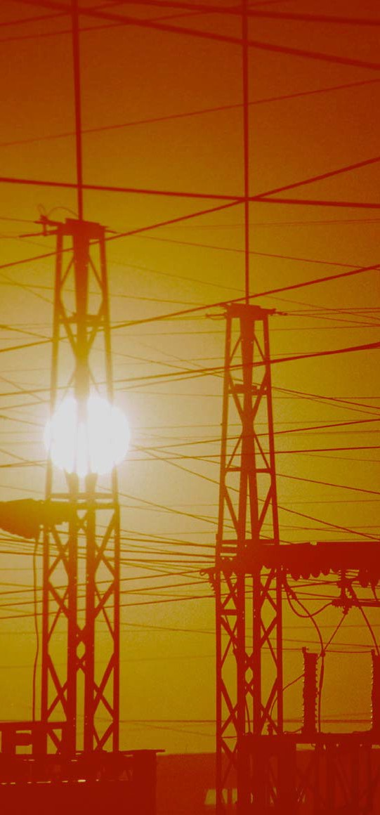
TCIP is funded by:
The National Science Foundation The Department of Energy
The Department of Homeland Security

For More Information:

Information Trust Institute University of Illinois at Urbana-Champaign
450 Coordinated Science Laboratory 1308 West Main Street, MC-228 Urbana, IL 61801

217.333.3546

info@iti.illinois.edu http://www.iti.illinois.edu
TCIP Educational Development is a joint project of the Office for Mathematics, Science and Technology Education and Information Trust Institute at the University of Illinois.
These materials were developed by Judy Rocke, Jana Sebestik and Zeb Tate in consultation with George Reese. http://tcipg.mste.illinois.edu/

Revised December, 2011

