Power Economics and Emissions

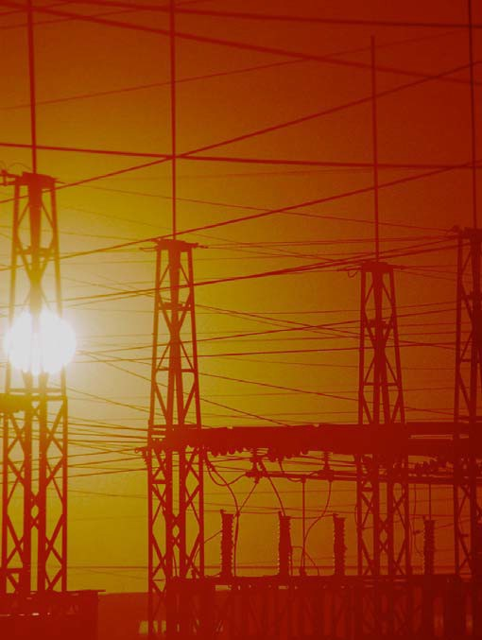

TCIP Educational Development
TCIPG: Trustworthy Cyber Infrastructure for the Power Grid

Communities and Payments

Power Economics and Emissions
Lesson 1

Comments for Teachers
The applet at http://tcipg.mste.illinois.edu/applet/eco shows a simulation of a large scale power system. This applet is
Encourage students to explore the applet. Then use the lessons on the student pages to focus and extend their explorations.

The reproducible Student Notebook with extensions and additional exercises offers larger images, maps, and charts and also gives student more room to write their r esponses.
an extension of The Power Grid applet http://

tcipg.mste.illinois.edu/applet/pg. Generators can be turned on and off.
Transmission lines are green when there is a safe amount of electricity running through them, and a line turns orange when levels exceed 85% of its capacity.
When a line capacity is exceeded the line turns red and a blackout occurs if the
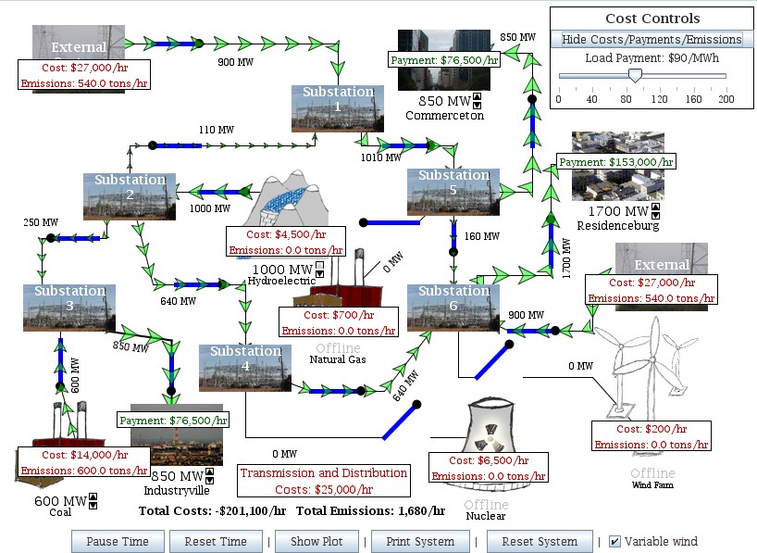
problem is not addressed by the system manager.
In this applet
there is information about Costs and Emissions
associated with the generators and Payments displayed for each of the communities. Even though a variety of factors determine the expenses associated with providing
electricity, the amounts consumers pay depend on the rate charged by the utility and how much electricity they use and the number of hours they use it. Click on the up or down arrows to change the power demanded by a community. (In this applet a community represents the sum of use by several residences or businesses.) The applet then adjusts the community’s payment based on the Load Payment rate. When the applet opens or the Reset System button is pressed, you can see that the Load Payment slider shows that the consumers are paying $90 per megawatt hour (MWh) or $.09 per kilowatt hour (kWh). Individual utilities set payment rates for their customers based on the utility’s costs. The Load Payment amount can be adjusted using the slider in the Cost
More Resources | Controls panel.
- Energy Information Administration - Official Energy Statistics from the U. S. Government. This agency was created by Congress in 1977 to provide unbiased energy information. http://www.eia.doe.gov/
- Electricity Explained, Factors Affecting Electricity Prices -
http://www.eia.gov/energyexplained/index.cfm?page=electricity_factors_affecting_prices
- Calculate Costs to Use Electricity at Webmath http://www.webmath.com/kwh.html
- Find out more about Hoover Dam and hydroelectricity at http://www.usbr.gov/lc/hooverdam/educate/ index.html and http://www.pbs.org/wgbh/amex/hoover/

Communities and Payments
Power Economics and Emissions Lesson 1

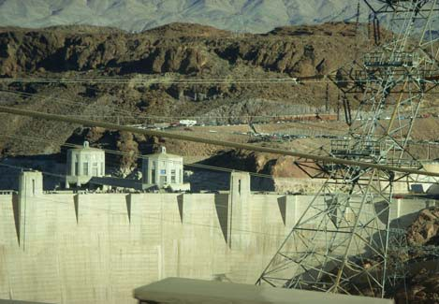Use the applet at http://tcipg.mste.illinois.edu/applet/eco to explore some of the econom- ics of generating and using electricity. In the applet there are five different types of generators delivering electricity to three communities. You can see the total payments per hour for each of the communities and the costs and emissions per hour for each

The hydroelectic power project at Hoover Dam is among the largest in the U.S. MSTE photo Ji-Young Kim
of the generators.
- Change the amount of electricity each of the communities is demanding. What else can you change?

When the applet opens or you press the Reset System button, the communities are paying $90
MW and MWh Notice that the power produced by the generators and demanded by the communities is measured in MW. This measure of power does not consider time. You could think of it as the production of the generator at one instant. When energy is sold or purchased, the price depends on the amount of power used per hour and can be measured in MWh.
These units (MW and MWh) measure large amounts of power and energy. When you purchase energy for your home it is measured in kWh. 1000 kWh equals 1 MWh.
per megawatt per hour (MWh) for the electricity they are using. The amount a customer pays depends on the rate charged, the amount of power used, and the number of hours it is used.
Notice the power demand from the three communities. Residenceburg is demanding 1,700 MW; Commerceton, 850 MW; and Industryville, 850 MW. These three locations are the consumers of the electricity. That is, they are the customers
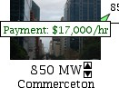
that purchase power from the system.
- How much are the total payments to the power producers from Industryville, Commerceton, and Residenceburg each hour?
- Click on the up or down arrow under the
Commerceton image to change the demand for electricity from this community. What happens when you click the up arrow? What happens when you click the down arrow?
Electricity is generated at power plants and then delivered to homes, businesses and industry. The entire system that includes transmission lines, substations and transformers is known as the power grid.

- How much is Commerceton’s payment per hour when the MW demand is 500 MW?
- What happens when you increase the demand from Residenceburg to 2000 MW? What about 2050 MW?

3

Generation Costs and Emissions

Comments for Teachers
Power Economics and Emissions
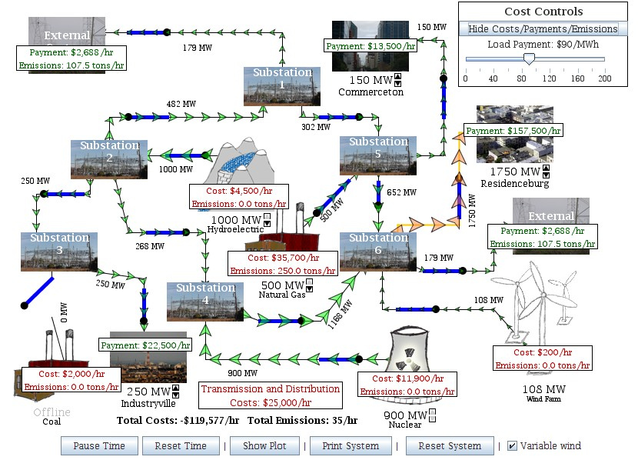Lesson 2

The Cost Control Panel has a button and a slider.

Excess power is flowing to the
External System Orange
transmission lines are above 85% of their capacity.

Fixed Costs include operating and maintenance, but not costs for construction.

Transmission and Distribution Costs in the applet remain constant for the utility and are prorated to the consumer.

Costs include fixed costs and fuel costs.
When fuel is burned to produce electricity carbon dioxide (CO₂) emissions are released into the atmosphere.

The Cost Control Panel has a button and a slider. - The button will hide or display the Payment boxes and the Costs and Emissions boxes shown on the applet. These are the white boxes shown on each consumer or generator of electricity. For each generator these boxes tell the amount of emissions of CO₂ per hour the generator is producing, and the cost of operation per hour in dollars. These emissions and cost amounts change when the MW output of the plant changes. For each of the three consumers of electricity payment per hour is shown. This payment changes as the consumers’ MW demand varies.
The slider will allow the Power Grid operator to change the amount the utility charges consumers for the electricity produced by the system. When the applet opens it charges $90/MWh.
Costs and Emissions are shown for each generator. - Carbon dioxide is produced when fossil fuels are burned. Carbon emissions from the Coal and Natural Gas generators are increased as the power each produces increases.
Fixed Costs - When any of the generators are not online, they still have costs. These costs include the operation and maintenance of the generators even when they are not producing electricity.
Examples of these expenses would include such costs as employees’ wages, costs associated with
buildings, state and local taxes, the cost of insurance, and the cost to
maintain the equipment.
More Resources
- EIA Energy in Briefs give information about several topics in easy to understand terms http://www.eia.gov/energy_in_brief/
- A virtual power plant tour provided by Salt River Project Power District www.srpnet.com/education/tour/

Generation Costs and Emissions
Power Economics and Emissions Lesson 2

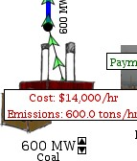When the applet at http://tcipg.mste.illinois.edu/applet/eco opens or the Reset System button is clicked, two generators are producing electricity and the coal generator is producing carbon dioxide emissions. There are costs and emissions associated with the power from the external system. We do not always know the source of this power so the applet uses an average based on representative generation types for the U. S.
- The applet shows costs and emissions information for each generator. Click the up and down arrows under the generators to change the produc- tion. What else changes.?

- Complete the chart below using information from the coal generator.
How do the costs and emissions increase with the increase in power production?
A power company incurs a variety of costs. All of these costs are reflected in the price consumers pay for electricity. Fuel costs vary depending on the type and availability of the fuel. There are transmission and distribution expenses associated with delivering the electricity from the generator to the consumers. There are also fixed costs or operating and maintenance costs. Even if a generator is not producing electricity, the machinery has to be maintained and the workers have to be paid.
There are costs associated with the buildings owned by the company, costs associated with new construction and taxes. Power companies incorporate these expenses into a per kilowatt hour (kWh) rate that helps determine the price they charge their customers.

Coal Generator Costs and Emissions
Power produced (MW) | Costs  ($ per hour) | CO₂ emissions (tons per hour)
0
300
400
500
600
700
- Switch the coal generator offline. What are the costs and emis- sions now?

When a generator is offline, there are no emissions or fuel costs, but there are still fixed costs associated with operating and main- taining the generator.
- How much are fixed costs for each generator?
Coal Natural gas Wind
Hydropower Nuclear

Payments

Comments for Teachers
Power Economics and Emissions
Lesson 3

Use the applet at http://tcipg.mste.illinois.edu/applet/eco and sample power bills to explore some of the factors that determine the price of electricity. This family used 2989 kWh of electricity during this summer
month. Notice that there are three

Total kWh 08/13/2008 2989.0000 Summer kWh 08/13/2008 2989.0000

ELECTRIC SERVICE BILLING DETAIL

DS - Residential (DS-1) Service From 07/17/2008 to 08/13/2008 Former Space Ht Acct 15k And Over
Customer Charge |  | $6.29
Meter Charge |  | $3.62
Distribution Deliv Chg Summer | 2,989.00 kWh @ $.03203000 | $95.74
Electric Environmental Adj | 2,989.00 kWh @ $.00081680 | $2.44
Instrument Funding Charge | 2,989.00 kWh @ $.00690000 | $20.62
Instrument Funding Credit |  | -$20.62
Rider EDR Charge | 2,989.00 kWh @ $.00037859 | $1.13
Total Delivery Service Amount |  |  | $109.22

Electric Supply (BGS-1) Service From 07/17/2008 to 08/13/2008
Purch Elec Summer | 2,989.00 kWh @ $.06385000 | $190.85
Market Value Adj | 2,989.00 kWh @ $.00150110 | $4.49
Rider PER Supply Cost Adj 2,989.00 kWh @ $.00070000 $2.09 Transmission Service Charge 2,989.00 kWh @ $.00318000 $9.51
Total Supply Amount $206.94

Taxes Service From 07/17/2008 to 08/13/2008
Illinois State Electricity Excise Tax $9.75
Total Tax Related Charges $9.75

Total Electric Charges $325.91

The electric supply charge is about
Total kWh 02/14/2008 6153.0000 Non-Summer kWh 02/14/2008 6153.0000
ELECTRIC SERVICE BILLING DETAIL
DS - Residential (DS-1)  Former Space Ht Acct 15k And Over  Customer Charge |  | Service From 01/15/2008 to 02/14/2008 | $6.30
Meter Charge |  |  | $3.62
Distribution Deliv Chg Non-Summer |  | 6,153.00 kWh @ $.01998000 | $122.94
Electric Environmental Adj |  | 6,153.00 kWh @ $.00096420 | $5.93
Instrument Funding Charge |  | 6,153.00 kWh @ $.00670000 | $41.23
Instrument Funding Credit Total Delivery Service Amount |  |  | -$41.23 | $138.79
Electric Supply (BGS-1) Service From 01/15/2008 to 02/14/2008
Non-Summer (0-800 kWh) |  | 800.00 kWh @ $.07957000 | $63.66
Non-Summer (Over 800 kWh) |  | 5,353.00 kWh @ $.01024000 | $54.81
Market Value Adj |  | 6,153.00 kWh @ $.00004400 | $0.27
Supply Cost Adj |  | 6,153.00 kWh @ $.00074000 | $4.55
Transmission Service Charge Total Supply Amount |  | 6,153.00 kWh @ $.00247000 | $15.20 | $138.49
Taxes | Illinois State Electricity Excise Tax | Service From 01/15/2008 to 02/14/2008  $19.85
 | Total Tax Related Charges | $19.85
Total Electric Charges $297.13

$0.069 per kWh. This is the type of charge that is shown in the applet as payment from the communities.
Remember, this is a bill for one month for just one family, and the community payment in the applet is for a large neighborhood. The electric supply cost varies from month to month.
At the right is a bill for the same family, but for a month during a Mid-
major billing categories. The total delivery service amount is $109. 22, the electric supply total is $206.94 and the tax total is $9.75.
The delivery charge is about $0.037 per kWh. This includes the charge for the wires that carry electricity and the meter and transformer pole or box near the house. These charges vary greatly from region to region. In the applet they are included in the amount, Transmission and Distribution Costs.

West winter. This family uses electricity for heat. Even though they use more kWh of energy during
this month, their electric bill is less. What else do you notice when you compare the two bills?
- Check the website for your local power utility for sample power bills and information about them
- Ameren Illinois Residential Customer Bill Sample. www.ameren.com/sites/aiu/CSC/Pages/ExamplesofSampleBill.aspx
- Ameren Illinois also offers an hourly pricing program http://www.powersmartpricing.org/
- Residential rate information from Sacramento Municipal Utility District. This utility uses a tiered rate system to encourage conservation. It also offers a voluntary program to users designed to lower demand during peak times. www.smud.org/en/residential/customer-service/rate-information/your-rates.htm
- Xcel Energy’s energy plans and rates vary from state to state. http://www.xcelenergy.com/Save_Money_&_Energy/For_Your_Home/Rate_Options
More Resources

Payments
Power Economics and Emissions Lesson 3

Use the applet at http://tcipg.mste.illinois.edu/applet/eco to explore some of the factors associated with the price of electricity. When the applet opens or you press the Reset System button the Load Payment slider is set at $90/MWh. 1. What

changes when you move the slider?

This map of the United States shows average residential retail prices in 2009 in cents per kWh of electricity for the entire U.S. and for individual states. Move the Load Payment slider to represent the U.S. average. Round to the nearest whole dollar per MWh.
- If one million people in Residenceburg each use an amount of electricity equal to two 100 watt light bulbs, the demand from the community is 200 MW. What is the per hour payment from Residenceburg for this electricity?
- If Residenceburg is in MN, then what is the payment from Residenceburg if the demand is 1000 MW?
DOE/EIA
Date of Data: 2009
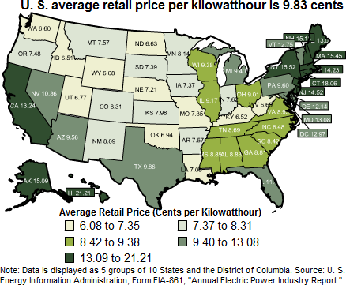
Data Release Date: April 2011 DOE/EIA-

Find more information and an interactive map at www.eia.gov/ectricity/sales_revenue_price/index.cfm

- Move the Load Payment slider to represent the retail price of electricity in your state. What is the payment for Residenceburg if the demand is 1800 MW?

- Which state has the highest price for electricity? Which has the lowest? Why do you think the states’ rates vary so much?

Utilities may have different rates for their business and industrial customers and may also vary their rates with the season. Look at some sample utility bills. You may be able to get sample bills and guidelines about how to read them from your local electric utility.

Generation and Delivery

Power Economics and Emissions
Lesson 4a

Comments for Teachers

The applet at http://tcipg.mste.illinois.edu/applet/eco is an example of a vertically integrated power system. This utility owns the generator plants and the transmission and distribution systems. In the applet transmission and distribution, fixed costs, and fuel cost rates remain

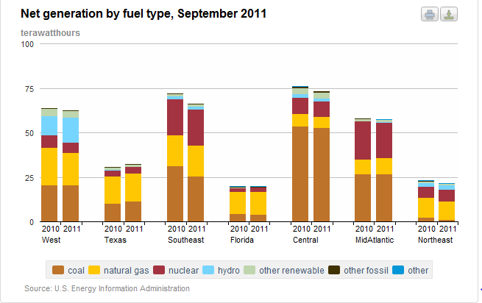constant. The user can adjust the Load Payments, demand from the communities and the power produced by the generators.
Find more information and an interactive graph at
Costs to produce electricity frequently change. Fuel sources and constantly changing demand are just two influences on the cost. Fuel availability and costs vary from region to region. Hydropower is plentiful in the Northwest, and eastern states use more nuclear power. More electricity is often needed in the afternoon and early evening hours. There is also a seasonal demand in most states for more
electricity in the summer when air

conditioners are used.
http://www.eia.gov/electricity/monthly/update/resource_use.cfm

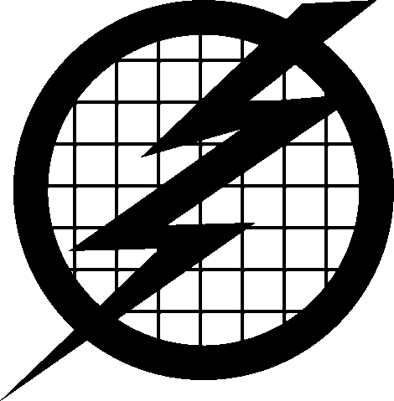Utilities prepare for changes in demand by using both base load and peak load generators. Base load generators are usually more efficient and are able to produce a consistent supply of power. Peak load generators are usually more expensive to operate, and are generally used to meet demands during “peak” or high use times. Their production can be changed quickly. In the applet the natural gas generator is a peak load generator. Hydroelectric generators use moving water to spin a turbine. Often, water is collected in a reservoir created by a dam and then released to flow through the turbine. Because they are efficient and easily controlled they are used for both base load and peak load.
In some areas consumers can choose a time of use plan that charges for electricity at two or more rates, a lower rate for using electricity during off-peak hours and a higher rate for on-peak times. Those consumers who can shift some of their use to off-peak times save money for themselves and for the power utility.
Transmission and distribution costs are all of those associated with getting the electricity from the generator to the user. Transmission and distribution is the “highway” for electricity. It includes
many sizes of wires, power poles, substations, transformers and meters.
More Resources
- Energy Information Agency Electicity Overview http://www.eia.gov/electricity/
- Central Iowa Power Cooperative’s Fundamentals of Electricity http://cipco.apogee.net/foe/home.asp
- State Energy Profiles - information about fuel sources, transmission lines, power plants, and renewable energy potential for each state http://www.eia.gov/state/index.cfm
- Educational resources from The Department of Energy Office of Electricity Delivery & Energy Reliability http://energy.gov/oe/information-center/educational-resources

Generation and Delivery
Power Economics and Emissions Lesson 4a

When the applet at http://tcipg.mste.illinois.edu/applet/eco opens or the Reset System button is pressed, two generators are producing electricity and three are not.
  - How much power is each generator producing? Coal Natural gas Hy-

dropower
Wind
Nuclear

  - How much is the total power production?
This graph shows energy sources for various regions of the U.S. Which sources are included in the “Renewables” category?
  - How much total power are the three communities de- manding?
  - Since these generators are not producing as much pow- er as the communities are demanding, the system needs to import power from the external system. How much power is the external system providing?
  - How much are the supply costs per hour (generators and external system)?

Coal
Natural gas
Hydropower
Wind

Nuclear External system total
The applet simulates a system that is owned by a power utility company. The company provides power to three communities. It owns and operates five types of generators and the transmission lines that serve the communities.
Within this system, it is usually possible for the utility company to supply all of the load demand using the local generators.
However, there could be many reasons why this is not possible or most profitable, and then electricity is purchased from or sold to the external system.
  - What is the cost for Transmission and Distribution?

  - What are the producer’s total costs? That is, how much per hour is the producer spending altogether (including the external system costs) to provide power to these three locations?
  - Are the power provider’s costs more or less than the payments from

the communities? loss?
How much is the provider’s profit or

  - What happens when you switch on the nuclear power plant?

Now how much is the provider’s profit or loss?
  - What happens when you switch on the wind farm?

How much is the provider’s profit or loss now?
  - Without changing the demand from the communities, maximize the provider’s profits. How much is the provider’s profit?
  - What did you do to maximize the profits?

9

Generation and Delivery

Power Economics and Emissions
Lesson 4b

Comments for Teachers

The applet at http://tcipg.mste.illinois.edu/applet/eco is an example of a vertically integrated electric power system. The generators and the
users are connected by the

Power Generation, Transmission, and Distribution
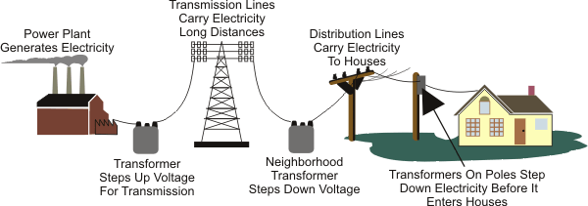
Source: Energy Information Administration
interconnected system. Using the applet is like operating the dispatch center, and the external system in the applet represents connections to the interconnected system.
Today nearly all power utilities in the United States belong to one of three major power grid networks, the Eastern Interconnected
transmission and distribution network. Dispatch centers communicate with the generators and are also authorized to buy and sell electricity to others within the

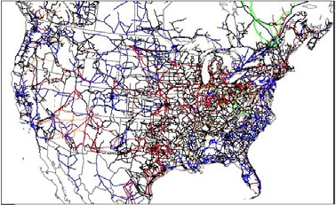Transmission in the Contiguous United States

System, the Western Interconnected System or the Texas Interconnected System. Regional entities within each interconnected system help power utilities coordinate their supplies and buy and sell from each other.
Electricity travels at near the speed of light through the “path of least resistance.” Its flow can only be controlled by opening and closing switches. Currently, there is no large scale storage of electricity. It must be produced as it is consumed. So power producers need to respond to the varying demand of their customers 24 hours a day.
As demand for electricity increased, local utility systems realized there were economic advantages and increased reliability with interconnection. The system we call the power grid grew out of these needs over several years. Regional Transmission Organizations (RTO’s), Independent System Operators (ISO’s), and local control area operators all work to keep the generation and transmission of electricity reliable and economical.
The North American Electric Reliability Corporation (NERC) was founded in 1968 by the electric utility industry. It is an independent not-for-profit organization that works with utilities in Canada,
the U.S. and northern Mexico to make the electric generation and transmission system safe and reliable.
- North American Electric Reliability Corporation http://www.nerc.com/
- U.S. Department of Energy; Office of Electricity Delivery and Energy Reliability http://energy.gov/oe
More Resources

Generation and Delivery
Power Economics and Emissions Lesson 4b

Use the applet at http://tcipg.mste.illinois.edu/applet/eco to explore how systems of electricity are interconnected. When the applet opens or you press the Reset System button, Residenceburg is using 1,700 MW per hour, Commerceton is using 850 MW per hour, and Industryville is using 850 MW per hour.
- What happens to the External System cost when each of these three locations increases the amount of power they need?

- What could cause each of these locations to have to increase the amount of energy they need?

- What could cause each of these locations to have a decrease in the amount of energy they need?

- Press the Reset System button. Currently, the system is spending $54,000 to purchase energy from external systems. Can you find a way to set the system so that this system does not have to rely on external systems to meet the needs of its customers?

- Complete these charts to show what changes you make to the system so that no power is going to or from the External System. How much of a profit or loss does your system have? What are the emissions?

Power Source | Cost of operation  (dollars per hour) |  | Amount of CO₂ Emissions  (tons per hour) |  | On-line or  Off-line? | Output  (MW)
Coal
Nuclear
Wind
Hydroelectric
Natural Gas
External Systems
Customers |  | Energy Demand (MW)
Residenceburg
Commerceton
Industryville
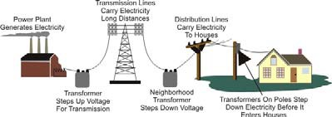
Source: Energy Information Administration
Dollars received from customers
Expense to provide power to customers (Be sure to include
the transmission and distribution costs!)
Total Emissions/hour

Utility Profits and Emissions

Comments for Teachers

Power Economics and Emissions -

Lesson 5

Use the plot with the applet at http://tcipg.mste.illinois.edu/applet/eco to explore some of the economics of generating and using electricity. When the applet opens the system is operating at a profit to the power utility.
Press the Show Plot button to see a plot like the one below.
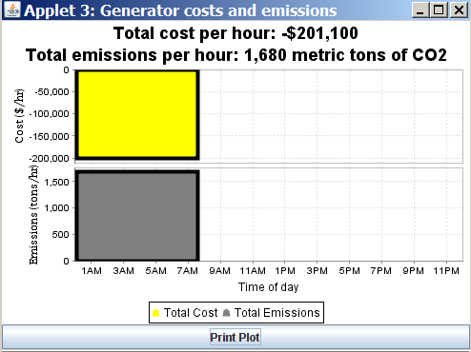
This plot displays two separate pieces of information that change over time as the settings of the grid change. The yellow section of the plot shows the total cost per hour of producing electricity for the power utility.
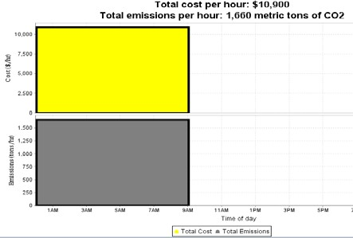
When the cost is positive, the utility is paying more for fuel and for its operating costs than the payments from the communities. If the costs are positive the utility is losing money. If the cost is zero, the communities are paying the utility exactly enough to equal the utility’s expenses. If the cost is negative, the payments are more than the utility’s expenses and it is making a profit.
Notice the load payment is $90/MWh and there is a nega- tive cost (-$201,900 per hour) to provide power to the cus- tomers of this utility. This amount comes from subtracting the total payments paid by the three consumers of electric- ity from the total costs of running all the generators plus the transmission and distribution costs. At this load pay- ment rate the utility’s costs are negative and it is making a profit.
It will show a loss, or positive cost, if the power utility takes in less money than it is spending. For example, reset
the system and the time, and change the Load Payment Slider to $30MWh. Turn on the Natural Gas generator. Display the plot and it now shows a loss of 10,900. It is shown as positive on the plot be- cause $10,900 is the amount of cost that is more than the revenue.
The gray part of the graph shows the amount of emissions for the utility system. The emissions shown in this plot are from the coal generator, the natural and the external system. Emissions come from burning fossil fuels.
Many power utilities have carbon offset programs that involve planting trees. These include large and urban forestry projects. “Eighteen electric utilities, reported 32 urban forestry projects for 2004. For the 32 projects, reported sequestration totaled 20,000 MTCO₂ Urban forestry projects are unique in that, under some circumstances, they can reduce energy consumption as well as sequester carbon. Shade trees planted near buildings reduce summer air conditioning requirements; in addition,
trees can act as windbreaks, reducing heating needs in the winter” (EIA Carbon Sequestration).
More Resources
- Energy Information Agency Environment Overview http://www.eia.gov/environment/
- Energy Kids, Greenhouse Gases http://www.eia.gov/kids/energy.cfm?page=environment_about_ghg-basics
- Renewable Resource Data Center at the National Renewable Energy Lab http://www.nrel.gov/rredc/
- What is Cap and Trade? http://www.eia.gov/energy_in_brief/cap_trade_program.cfm

Utility Profits and Emissions
Power Economics and Emissions Lesson 5

  - Use the applet at http://tcipg.mste.illinois.edu/applet/eco to explore some of the economics of generating and using electricity. Press the Reset System button, then press the Reset Time but- ton and the Show Plot button. Let the system run until the graph shows several hours. Press Pause Time. You should see a plot that looks like the one below. What does it show?

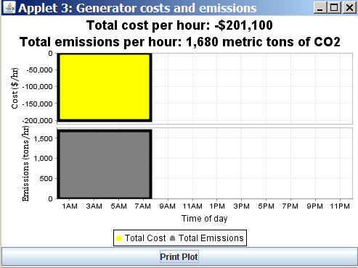
The yellow part of the graph shows the cost per hour to the utility. When the cost is negative, the utility’s costs are less than the payments from the communities and it is making a profit.
  - How much profit per hour does the graph
show for the utility? Is this
the same as you calculated in lesson 4?

  - The grey part of the graph shows the carbon dioxide (CO₂) emissions produced per hour. How much CO₂ is the system producing?
  - These plots show costs and emissions for about eight hours. During that time period how much profit did the utility make? and how many metric tons of CO₂ were released
into the atmosphere? Why are we concerned about both costs and emissions?

  - 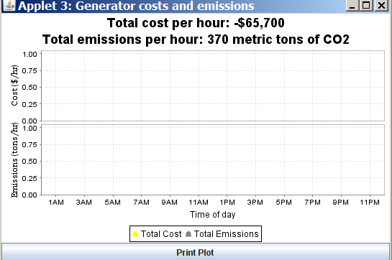Press the Reset Time button. Keep the power demand from Residenceburg at 1700 MW and from Commerceton and Industryville at 850 MW each. Adjust the system so that the utility is making a profit and the CO₂ emissions are lower than 1000 metric tons per hour, then click the Show Plot button, and let the system run until the graph shows several hours. Then press Pause Time. Shade this plot to look like what you see.
  - How much power and CO₂ are each of the generators pro- ducing?
Coal Hydro Wind Nuclear Natural Gas External System

Emissions and Climate Change

Power Economics and Emissions -
Lesson 6

Comments for Teachers

Sulfur dioxide (SO₂), nitrogen oxides (NO_{x}), and carbon dioxide (CO₂) are among the gases emitted during the burning of fossil fuels. Only CO₂ emissions are shown in this applet. Sulfur dioxide and nitrogen oxides cause acid rain. There are ways of reducing these emissions

which can reduce their effects. Electric generators can use coal that contains less sulfur, wash the coal, or use scrubbers. Scrubbers chemically remove SO₂ from gases that leave smokestacks. However, all these options increase the cost to produce electricity.
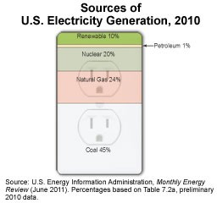
CO₂ is a major contributor to the increase of greenhouse gases. Greenhouse gases allow sunlight to enter our atmosphere. Then when the sunlight reflects off the surface the gases hold heat in our atmosphere. Without greenhouse gases the earth would be too cold, but too much CO₂ production is causing the temperature of our atmosphere to rise too much. When coal, oil, or natural gas are burned they produce greenhouse gases. Fossil fuels are made of hydrogen and carbon. When these fuels are burned the carbon combines with oxygen to release carbon dioxide . Burning natural gas releases about one half of the amount of carbon dioxide as burning coal. Burning oil releases about three-
fourth the amount. Using fossil fuels to produce electricity, heat our homes and businesses or operate our vehicles increases the amount of CO₂ in the atmosphere.
Deforestation also increases the amount of carbon dioxide in the air. Forests offset human produced carbon emissions through photosynthesis. The amount of carbon absorbed depends on the size of the tree. A large sugar maple can remove 450 pounds of carbon dioxide in a year. At that rate 31 trees per operating automobile in the United States would offset all U.S. automobile- related carbon dioxide emissions.
Energy experts recognize the importance of reducing the production of harmful gases, but also want to keep energy costs low. Using the applet at http://tcipg.mste.illinois.edu/applet/eco demonstrates aspects of balancing costs and emissions while meeting consumer demand. Legal authority for energy policy belongs to individual states. Some states require electricity producers to use renewable sources for specified percentages of their power production and many states
also have guidelines for reductions of greenhouse gas emissions.
More Resources
- U.S. Environmental Protection Agency Climate Change http://www.epa.gov/climatechange/
- EPA’s website, Climate Change for Kids, has information about green house gases and climate change for teachers and students http://epa.gov/climatechange/kids/
- State-specific information from the U.S. Department of Energy's (DOE's) Office of Energy Efficiency and Renewable Energy (EERE) http://apps1.eere.energy.gov/states/state_information.cfm
- Information about acid rain http://www.policyalmanac.org/environment/archive/acid_rain.shtml

Emissions and Climate Change
Power Economics and Emissions Lesson 6

Use the applet at http://tcipg.mste.illinois.edu/applet/eco to explore carbon dioxide emissions produced when generating electricity. Press the Reset System button. Then turn on the Natural Gas, Nuclear and Wind Generators so all of the generators are producing.
- Look at the Coal Generator. Notice the Coal Generator power output is 600MW and it has carbon dioxide emissions of 600 tons per hour. Change the amount of power produced. How do the emissions change?

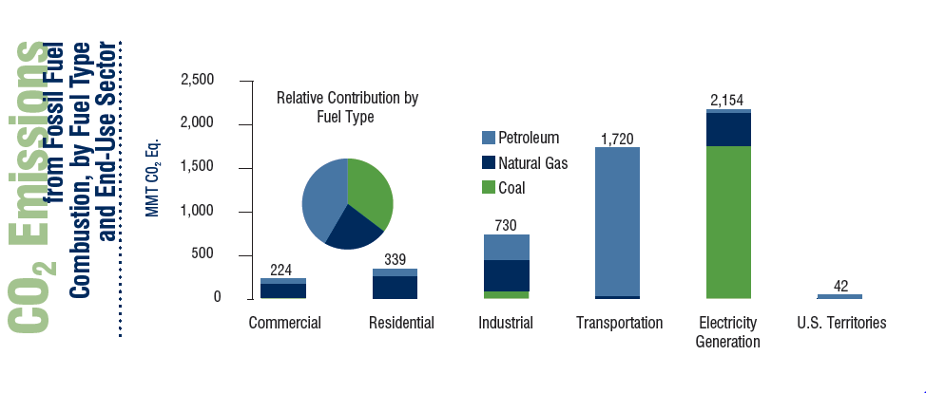Among the gases emitted during the burning of fossil fuels are sulfur dioxide (SO₂), nitrogen oxides (NO_{x}), and carbon dioxide (CO₂). Sulfur dioxide and nitrogen oxides cause acid rain. There are ways of reducing these emissions which reduce acid rain. For example, generators could use types of coal that contains less sulfur, wash the coal, or use scrubbers. Scrubbers chemically remove SO₂ from gases that leave smokestacks. However, all these options increase the cost to produce electricity.
Carbon dioxide is a greenhouse gas. Greenhouse gases allow the sun’s energy to enter the Earth’s atmosphere and then trap some of this heat causing the Earth’s temperature to rise. Without greenhouse gases the Earth would be too cold for human life, but in recent years the amount of green- house gases in the atmosphere has been increasing and the temperature of the Earth is rising.
Scientists are concerned that even a small increase in the global temperature could have serious consequences.

- The emissions shown in this applet are carbon dioxide (CO₂) emissions. Carbon dioxide is a greenhouse gas. Which generators produce CO₂ emissions?

- How do the emissions for the Coal Generator compare to the emissions for the each of the other generators?

- How do the emissions change as the power production changes?

- This graph shows sources of CO₂ emissions for the United States in 2006. What information does the graph give you?

Source: U.S. Greenhouse Gas Emissions Inventory (y-axis units are metric tons of CO2 equivalent).

15

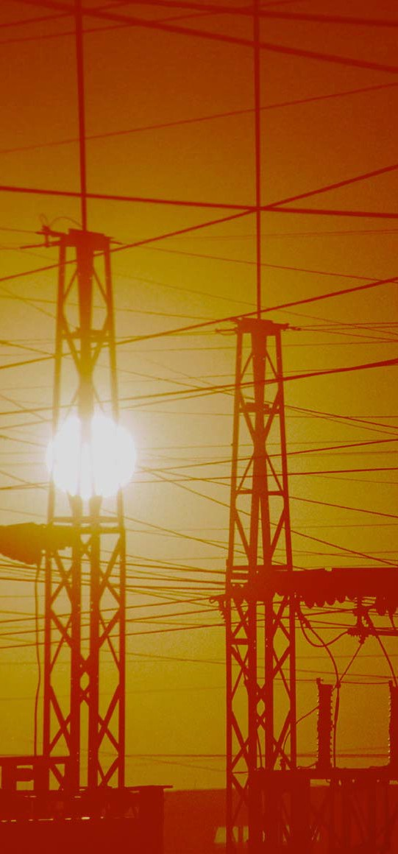
TCIP is funded by:
The National Science Foundation The Department of Energy
The Department of Homeland Security

For More Information:

Information Trust Institute University of Illinois at Urbana-Champaign
450 Coordinated Science Laboratory 1308 West Main Street, MC-228 Urbana, IL 61801

217.333.3546

info@iti.illinois.edu http://www.iti.illinois.edu
TCIP Educational Development is a joint project of the Office for Mathematics, Science and Technology Education and Information Trust Institute at the University of Illinois.
These materials were developed by Judy Rocke, Jana Sebestik and Zeb Tate in consultation with George Reese.
http://tcip.mste.illinois.edu/

