Power and Energy in the Home

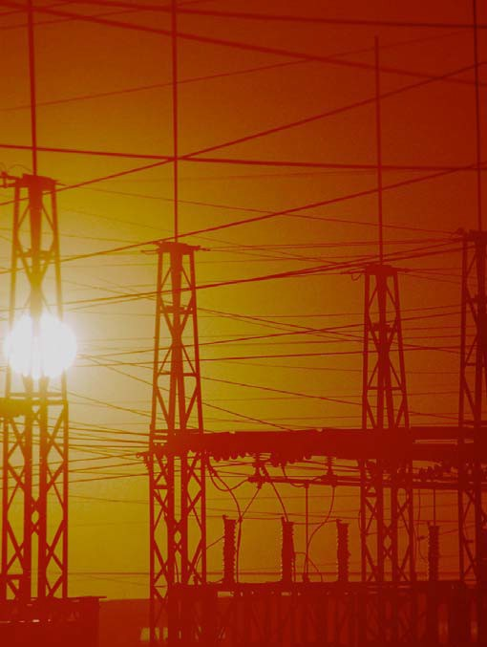

TCIP Educational Development
TCIPG: Trustworthy Cyber Infrastructure for the Power Grid

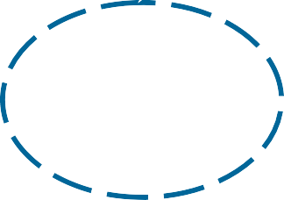Power and Energy in the Home

Comments for Teachers
Lesson 1 This lesson uses the applet at http://tcipg.mste.illinois.edu/applet/peh

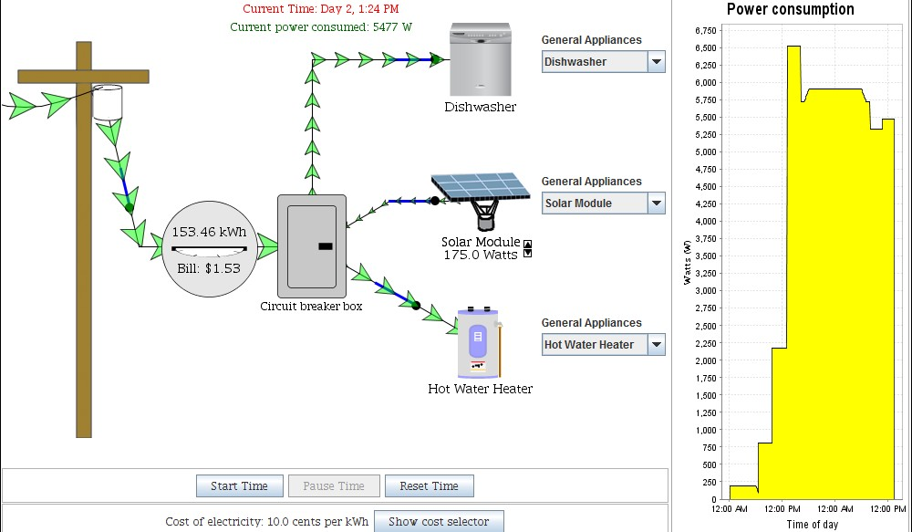The applet shows power flowing through the transformer drum, the kilowatt-hour meter and into the circuit breaker panel. From the panel it powers various appliances including video game consoles, kitchen appliances, and light bulbs.
When the applet opens time is passing
and the kWh meter is running. The meter shows the energy used since time started and the cost of that energy at $.10 per kWh. Elapsed time (hours and minutes) and Current power consumed are displayed near the top. Remind students that energy use and cost are determined by the amount of power used and the amount of time it’s used. The graph shows power consumed over time. The yellow area represents the energy used.

Encourage students to explore the applet. There are blue switches to open and close by clicking with the mouse. Choose appliances from the drop down menus and see the flow of power increase and decrease. Use the mouse to click the blue switches near the appliances. These switches act like the circuit breaker switches in the circuit breaker panel. In your home, however, one circuit breaker switch may control the flow of electricity to an entire room of appliances. When you click open the blue switch nearest the transformer all of the power stops flowing. Students can explore various combinations of appliances with opened and closed switches and view the changes in Current power consumed, the meter readings and in the arrow sizes.

- Home Energy Saver http://hes.lbl.gov/
- Energy Savers Website http://www.energysavers.gov/
- Energy Information Administration’s Energy Kid’s Page http://www.eia.gov/kids/
More Resources

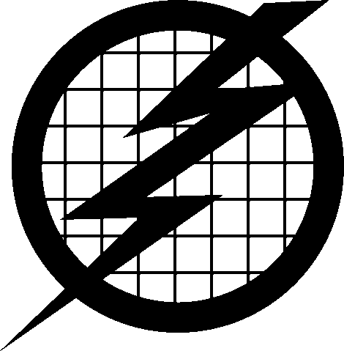1

Power and Energy in the Home
Lesson 1

Use the applet at http://tcipg.mste.illinois.edu/applet/peh to explore power usage in the home. Open and close the blue switches and use the drop down menus to change the appliances.

Watch how the flow of power changes. What do you see?

- 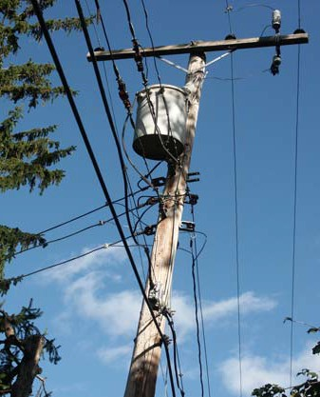List three of these appliances that you might use for an hour or more. (1
Electricity comes
from a power Read about the power
plant to your home grid here.
through a system
of power lines, power
substations, and transformers that make up the power grid.
Power flows through a transformer drum on a power pole into a kilowatt- hour meter. The meter measures the amount of energy going into the home so
the power company knows how much to bill the people who live there. An apartment building may have a meter for each apartment.
(2 (3
- Set the blue switches so only the Energy Star refrigerator (E-Star Fridge) is on. What is the Current power consumed? (It’s the green number near the top.)

- Compare the Energy Star refrigerator with the standard refrigerator. About how much more power does the standard refrigerator use?

- How much power does the plasma television use?

- Which of the three video game systems uses the least power?
- Energy is sold by the kilowatt hour. A kilowatt is one thousand watts. If you use the 1000 watt hair dryer for one hour, you use 1 kWh (one kilowatt hour) of energy. How much energy is used if you dry your hair for 15 minutes?
- Using a 100 watt light bulb for one hour uses 0.1kWh of
energy. How many kilowatt hours do you use when you leave a standard 100 watt light bulb on for two hours?
for six hours?
- If your XBOX 360 and 40” LCD TV are on for ten hours, how much energy is used?

Power and Energy in the Home

Comments for Teachers
Lesson 2 This lesson uses the applet at http://tcipg.mste.illinois.edu/applet/peh

The applet shows power flowing through the transformer drum, the kilowatt-hour meter, the cir- cuit breaker panel, and into various appliances. If you keep the blue switch to only one of the ap- pliances closed, the Current power consumed display shows the power needed for that one appli- ance. If you reset and start time the meter shows the energy used and the bill. Energy use and cost depend on both the amount of power needed and the time it is used.

There are solar modules in the lists of appliances. You can adjust the output by clicking on the arrows. A homeowner would typically have several panels. In this applet the solar module is grid-
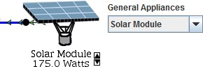
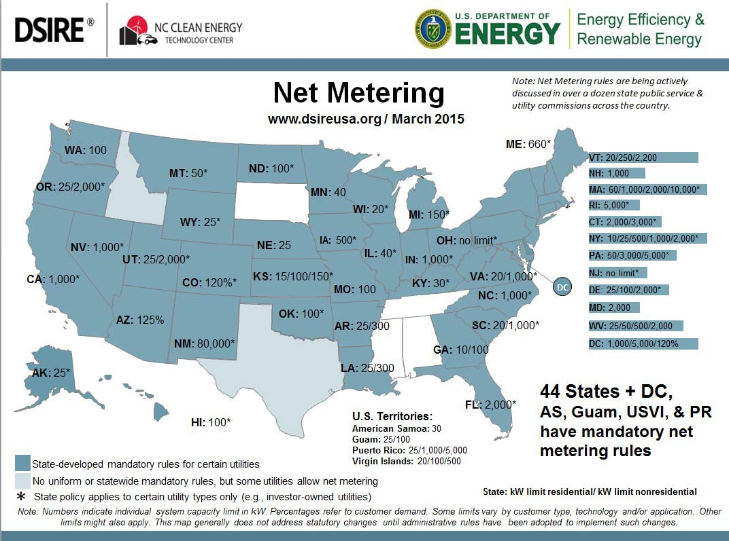connected. This means that the solar module is a contributor to the power needs of the household when it is needed, but if the household needs more than the solar module is producing, additional electricity is

delivered from the power utility, and if the solar module is producing more power than is needed, the excess flows into the power grid to be used by others.
Most states have net metering programs that allow the meters of power customers to turn backward when the solar module (or wind turbine) is producing excess energy.
Information from the U.S. Department of Energy, Energy Efficiency and Renewable Energy Office
- PV Watts Calculator http://pvwatts.nrel.gov/
- Solar Energy http://www1.eere.energy.gov/solar/
- Green Power Marketing and Net Metering http://apps3.eere.energy.gov/greenpower/markets/netmetering.shtml
- Small Solar Electric Systems http://www.energysavers.gov/your_home/electricity/index.cfm/mytopic=10710
More Resources

3

Power and Energy in the Home Lesson 2

Use the applet at http://tcipg.mste.illinois.edu/applet/peh to explore power usage in the home. Open and close the blue switches and use the drop down menus to change the appliances. Which appliances need a lot of power?

- Set the blue switches so only the toaster is on. What is the Current power consumed?
Some appliances need a lot of power, but we don’t often use them for a long time period so they don’t use much energy.
Other appliances may not need as much power, but they are used for more time. Energy use and cost depend on both the amount of power needed and time it’s used. Which appliances use a lot of power and are on for longer time periods?
- Click on the Pause Time, Reset Time and then Start Time buttons. Watch the energy use and energy cost change on the kWh meter. You should also see the Elapsed time total changing. If you use the toaster for ten minutes how much energy do you use?
When the cost per kWh is 10 cents per kWh, how much do you pay to use the toaster for ten minutes?

- Use the applet to fill in the table.

Appliance | Power needed | Time | Energy used | Bill
Microwave |  | 15 minutes
40” LCD TV |  | 3 hours
Vacuum |  | 30 minutes
Iron |  | 2 hours

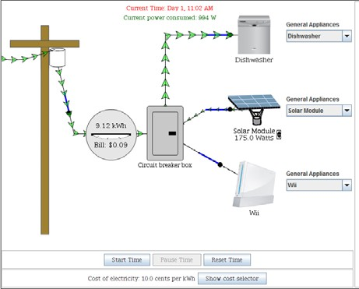
- Set the switches so only one solar module is connected. Vary the output. What happens?

- How can you set the output of the solar module so that it can power the Playstation and the LCD TV?

- Which appliances need less power than one 175W solar module can supply?

Comments for Teachers
Power and Energy in the Home
Lesson 3 This lesson uses the applet at http://tcipg.mste.illinois.edu/applet/peh
Power and Energy units
Watt—basic unit of power

Watt hour—a unit of en- ergy; one watt of power delivered over one hour

Kilowatt—1000 watts

Kilowatt hour—one kilo- watt of power delivered over one hour

Megawatt—1,000,000 watts
In the applet the meter between the power pole and the

circuit breaker box measures the energy being used as time passes. Elapsed time and Current power consumed are shown near the top. When the applet opens, the dishwasher, ceiling fan and the personal computer are demanding a total of 1341 watts of power. After one hour the meter shows 1.35 kWh’s of energy used and the bill is $.13. The meter continues to run for 3 days, 59 minutes unless the Pause Time button is clicked. When you change the appliances or open and close the blue switches, the demand for power changes and is shown in the Current power consumed tabulator.
If you change the appliances, the power demand will increase or decrease and the meter will adjust and spin faster or slower just like the wheel that spins in the meter at your home. The meter shows the cost of the energy at a rate of ten cents per kilowatt hour. If the only appliance you are using is a
100 watt light bulb, the cost of the energy is one cent per hour. Disconnecting the power pole stops energy usage and power demand. The meter stops but doesn’t reset to zero. Time is still passing.
There are buttons at the bottom of the applet.
- Clicking Pause Time pauses the Elapsed time clock. The meter stops measuring kWh and cost because energy is only consumed as time passes.
- Clicking Start Time starts the meter and the Elapsed time clock to begin tabulating again from
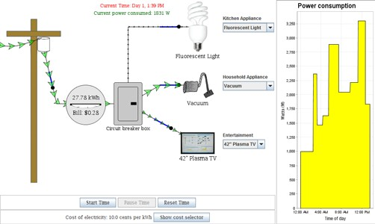
where they were paused.

  - Clicking Reset Time sets the meter and Elapsed time back to zero.
  - The Print button allows you to print the applet.
  - Clicking Show cost selector opens a slider that allows you to change the retail price.
  - The Power consumption graph shows how the energy use changes.
- Energy Star Products http://www.energystar.gov/index.cfm?fuseaction=find_a_product.
- U.S. Department of Energy’s educator’s page http://energy.gov/science-innovation/science-education
More Resources

Power and Energy in the Home
Lesson 3

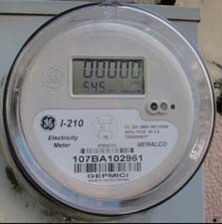Use the applet at http://tcipg.mste.illinois.edu/applet/peh to explore power usage in the home. Close some or all of the switches and then click on the Pause Time, Reset Time and then Start Time buttons. You should see the energy use and energy cost change on the kWh meter. You should also

Much of the electricity that we use is produced by steam-
powered turbines. Coal or natural gas is burned to make the steam. When we conserve energy in our homes, schools and businesses, less fuel is burned so fewer greenhouse gases are released into the air
see the Elapsed time total changing at the top of the applet. (Click the
Pause Time, Reset Time and Start Time buttons to start over.)
- How does the bill change as you change appliances and open and close the various switches?

Click Show cost selector and change the cost of the electricity to ten cents per kilowatt hour. Use the questions below to explore the applet more.
- Turn on the incandescent light, the room A/C and the XBOX 360. What is the Current power consumed by these three appliances? Reset and Start Time and then keep them all on for six hours. Read the meter

and the power company
charges us for fewer kilowatt hours so we save money too.
to find the total energy usage. energy?
What is the cost of that

- Turn on the incandescent light bulb, the Energy Star ceiling fan and the 40” LCD television. Reset
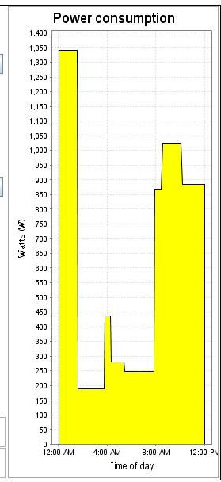
and Start Time and then Pause the time at one hour. What is the total energy consumed?

- Notice the graph of Power Consumed Over Time. Since you Paused time in the previous exercise, you should see a graph for 341 watts used for one hour. Change the appliances and Start Time. (Click Reset Time to start over.) How does the graph change as you change appliances and open and close the various switches?

Comments for Teachers
Power and Energy in the Home
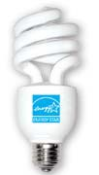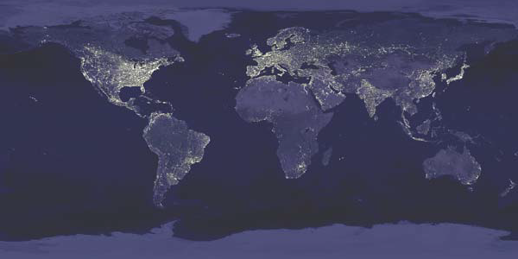Lesson 3 page 2 This lesson uses the applet at http://tcipg.mste.illinois.edu/applet/peh

At the very bottom of the applet is the Show cost selector button. Clicking on this button shows a slider that allows you to change the cost of a kilowatt hour of electricity. The average retail price of electricity in the U.S. is around $.10 per kWh. Electricity in the Midwest and Plains states is less expensive than on the coasts. The three states having the highest average rates are Hawaii, Connecticut and New York. Find the Electricity Monthly Update from U.S. Energy Information Administration at www.eia.gov/ electricity/monthly/update/end_use.cfm.

This is what the Earth looks like at night. You can see areas where lights are on outdoors at night. The image is actually a composite of hundreds of pictures made by the orbiting satellites.
http://eoimages.gsfc.nasa.gov/images/imagerecords/55000/55167/ earth_lights_lrg.jpg

More Resources
Information about Using Compact Fluorescent Light bulbs (CFL bulbs)
- The average U. S. household spends 15% to 20% of its energy dollars on lighting.
- Incandescent bulbs produce as much as nine times more heat than light.
- CFL’s produce almost no heat. They won’t burn you if you touch them and they also reduce cooling costs.
- The purchase price of a CFL bulb is more, but it lasts about ten times as long as an incandescent bulb.
- CFL bulbs contain a small amount of mercury. Get the Mercury Fact Sheet from Energy Star at http:// www.energystar.gov/index.cfm?c=cfls.pr_cfls_mercury
- Saving energy saves money and also reduces carbon dioxide produced by fossil fuel powered power plants.
- National Geographic has produced a video, This Bulb, promoting CFL bulbs. You can see it on YouTube at http://www.youtube.com/watch?v=dvUVXwJQcco

- Energy Savers offers tips for shopping for energy efficient lighting including information about LED lighting. http://energy.gov/energysaver/lighting-choices-save-you-money
- LUMEN Coaltion offers information about various lighting choices There is also information about The Energy Independence and Security Act (EISA) of 2007, signed by President George W. Bush on December 18, 2007.
ENERGYSTAR@home allows the user to click on areas of the home and learn about saving energy http://www.energystar.gov/index.cfm?fuseaction=popuptool.atHome
- Energy Star light bulbs http://www.energystar.gov/index.cfm?c=cfls.pr_cfls

Power and Energy in the Home Lesson 3 page 2 Use the applet at http://tcipg.mste.illinois.edu/applet/peh to explore power usage. Click on the
Show cost selector button. Set the applet so the cost of electricity is $.10 per kilowatt hour. The average cost of electricity in your state may be higher or lower.
- Turn on only the LCD TV and the Wii. Reset and Start Time. After 40 minutes turn on the standard fridge. How much energy is used when the elapsed time is one hour? What is

Energy Star is a joint program of the U. S. Department of Energy and the U. S. Environmental Protection Agency. A
the cost of that energy?
- Compare the incandescent light bulb with the fluorescent bulb. If a lamp is on for six hours, how much energy is saved by using the CFL bulb?
How much money?
- How many light bulbs do you think there are in your home?

product with an Energy Star How many hours are light bulbs on per day? per

label has met strict energy- efficiency criteria set by EPA and DOE. Energy Star promotes using energy wisely, and offers information for using less energy. Visit Energy Star Kids www.energystar.gov/ index.cfm?c=kids.kids_index
month? How much energy could you save per month if you replaced them all with CFL bulbs? How much money?

- Find out if your local electric utility offers discounts or incentives for purchasing energy saving light bulbs. Describe it here.

One household can save energy and money by changing incandescent bulbs for CFL bulbs, and if many households change their light bulbs, the energy savings per month or per year is more dramatic.
Hours of Use | Energy Consumed by One incandescent bulb (kWh) | Energy Consumed by One comparable CFL (kWh) | Energy Saved by replacing one bulb (kWh) | Energy Saved by replacing 1,000,000  bulbs (kWh) | Cost of the energy at $0.10 per kWh  (1,000,000  bulbs) | Cost of this energy at $0.18 per kWh  (1,000,000  bulbs)
1 | 0.1 | 0.033 | 0.067 | 67,000 | $6700 | $12,060
2 | 0.2 | 0.066 | 0.134 | 134,000 | $13,400 | $24,120
3 | 0.3 | 0.099
10
300
3600

A chart can help us organize the information for large numbers.
Complete the chart.
“If every American home replaced just one light bulb with an ENERGY STAR qualified bulb, we would save enough energy to light more than 3 million homes for a year, more than $600 million in annual energy costs, and prevent greenhouse gases equivalent to the emissions of more than 800,000 cars.” - www.energystar.gov

Power and Energy in the Home

Comments for Teachers
Lesson 4 This lesson uses the applet at http://tcipg.mste.illinois.edu/applet/peh

The graph on the right side of the applet shows time in hours on the horizontal axis and power demand on the vertical axis. As
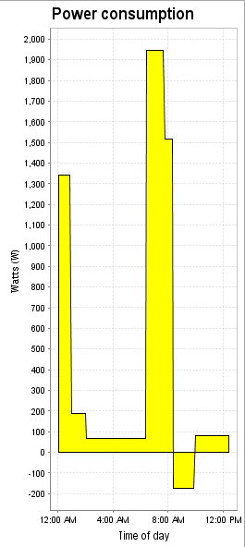
energy is used in the applet, the amount of energy being used appears as a yellow area. As the energy use changes the area changes. Time can continue to run for 3 days, 23 hours, 59 minutes.

One possible story for this graph

At midnight on Day 1 the dishwasher, fan and PC were all on. They all remained on for about one hour. Then the dishwasher turned off , but the fan and the PC remained on for a little more than another hour. Next the PC was turned off, the fan remained on and a CFL was turned on. Nothing changed un-
til approximately 6:30 AM

The yellow area in the Power Consumed Over Time graph is the amount of energy consumed. A rectangle 1 hour wide and 1000 watts tall indicates one kilowatt hour.
Find the number of kWh consumed by finding the total yellow area.

when the microwave and LCD TV were turned on. At 7:45 the fan and the TV were off and the solar module was pro- ducing power, and at 8:15 no appliances were using power. From 9:30 to about 12:30 the solar panel continued to pro- duce while the PC and one CFL bulb were on. .

- Safe Electricity http://www.safeelectricity.org/
- General Electric Energy Cost Calculator - This site has a variety of calculators. http://www.csgnetwork.com/elecenergycalcs.html
- Official Energy Statistics from the U. S. Government http://www.eia.gov/
More Resources

Power and Energy in the Home
Lesson 4

The graph below was produced by opening and closing the switches for the various appliances in the applet at http://tcipg.mste.illinois.edu/applet/peh It show
the energy used from midnight until noon.
Complete the story describing which appliances are on and for how long.

At midnight on Day 1 the dishwasher, fan and PC were all on. They all remained on for about one hour. Then the dishwasher turned off , but the fan and the PC remained on for a little more than another hour. Next the PC was
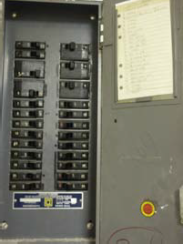

After the power goes through the meter it goes through a
circuit breaker panel. Inside the circuit breaker panel at the top are wires bringing power in from the transformer. There is a main circuit breaker here that can switch off all the power to the house. There are also more circuit breaker switches for each of the separate circuits for various parts of the house. The circuit breaker is a safety device. The circuit breakers can be
switched off manually, but if too much current is flowing through because there is a dangerous wiring or equipment problem the breaker switches off automatically.
Write your own power use story or extend this story. Use the applet to make a graph to illustrate it.

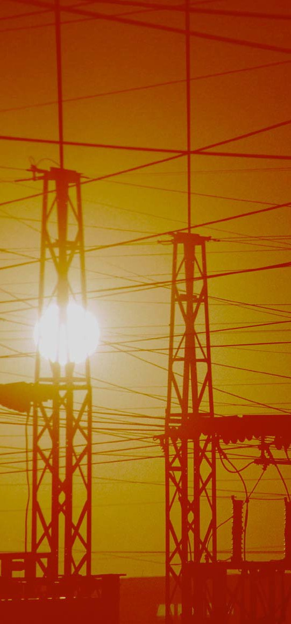

TCIP is funded by:

The National Science Foundation The Department of Energy
The Department of Homeland Security http://tcip.iti.uiuc.edu

For More Information:

Information Trust Institute University of Illinois at Urbana-Champaign
450 Coordinated Science Laboratory 1308 West Main Street, MC-228 Urbana, IL 61801

217.333.3546

info@iti.uiuc.edu http://www.iti.uiuc.edu
TCIP Educational Development is a joint project of the Office for Mathematics, Science and Technology and Information Trust Institute at the University of Illinois.
These materials were developed by Jana Sebestik and Zeb Tate in consultation with George Reese and Molly Tracy http://tcipg.mste.illinois.edu/

